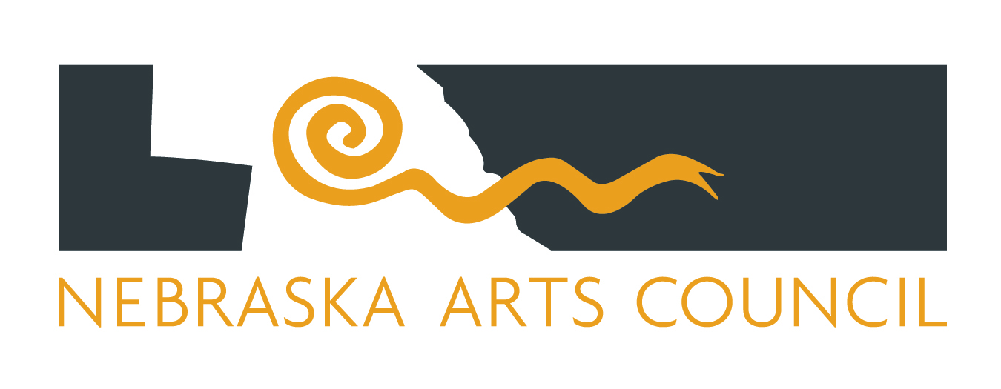

MINUTES
Quarterly Council Meeting
September 6, 2016
2:00 – 4:00 pm
Ortner Center, Union College
Lincoln, NE

I. Call to Order Candy Henning, Chair
A copy of the Nebraska Open Meeting Act is available for audience members. Additionally, there is a copy of all reproducible written material that will be discussed available for examination and copying by members of the public pursuant to the provisions of the Nebraska Open Meeting Act.

Ms. Henning called the meeting to order at 2:00 p.m. and invited anyone present to take advantage of the agenda and other materials furnished under the provisos of the Nebraska Open Meeting Act.

II. Roll Call Mike Markey

Present: Patrick Drickey, Tim Hart, Jon Hinrichs, Candy Henning, Darrel Huenergardt, Mark Laughlin, Kathy LeBaron, Melissa Marvin, Paula Pflueger, Pamela Price, Sue Roush, Harvey Varenhorst, Reven Wright

Absent: Julie Jacobson, Sherry McClymont

Also attending: Anne Alston, Launa Bacon, Marian Fey, Jane Ji, Mike Markey, Rachel Morgan, Kalee Olson, Carla Podraza, Suzanne Wise, Doug Zbylut

III. Approval of Agenda
Ms. Henning asked council members to review the agenda for any additions or corrections.

MOTION: Dr. Hinrichs moved to approve the agenda for the September 6, 2016 meeting. The motion was seconded by Ms. LeBaron.

VOTE: The agenda for the September 6, 2016 meeting was unanimously approved by roll call vote.

IV. Introduction of Guests & Oral Communications

- LuAnn Davis, vice president for advancement at Union College, welcomed the council to Union College and gave a brief presentation on the college and its 125th anniversary.

- NAC Vice Chair Mark Laughlin was recognized for his two terms of service. Suzanne Wise remarked that technically, his term was up on September 2, but until the Governor appoints a replacement, he will serve until replacement, which may or may not be by the December meeting. Mr. Laughlin acknowledged the gift and round of applause saying it has been his privilege to serve.

V. Approval of the Minutes for June 7, 2016

Ms. Henning asked council members to review the agenda for any additions or corrections.

MOTION: Ms. LeBaron moved to approve the minutes of the June 7, 2016 council meeting. The motion was seconded by Dr. Hinrichs.

VOTE: The minutes for the June 7, 2016 meeting were unanimously approved by roll call vote.

VI. Financial Report Tim Hart, Chair, Finance Committee
- Review of FY2015 – Michael Markey, NAC Director of Administration, gave a brief description and overview of all funding categories for the close of FY15. He directed the group to page 11 of the council packet and FY15 year end numbers, noting that numbers from the state and council records match. He noted that 82% of administration funds were expended and additional funds have been carried over into FY16. In addition, 95% of grant funds were expended for FY15.

MOTION: Ms. Marvin moved that the council approve the financial statement for FY15. The motion was seconded by Mr. Hart.

VOTE: The Finance Committee report was unanimously approved by roll call vote.

- Review of FY2016, YTD
Mr. Markey directed the group to page 21 of the council packet and numbers for July, noting that numbers from the state and council records match. He noted that 6% of administration funds have been used so far. In addition, he noted that 11% of grant funds have been paid out for FY16 and no expenses for Program 329.

MOTION: Mr. Hart moved that the council approve the financial statement for FY16. The motion was seconded by Ms. Price.

VOTE: The Finance Committee report was unanimously approved by roll call vote.

- Returned grant funds
Mr. Markey directed the group to page 28 of the council packet noting that the Nebraska Cultural Endowment has returned grant funding that was not needed for its current fiscal year.

MOTION: Mr. Hart moved for all funds returned from NCE be added to the money available for grants distributed following the October 1 deadline. The motion was seconded by Ms. Price.

VOTE: The motion was unanimously approved by roll call vote.

- Biennial budget
Mr. Markey shared the agency’s biennial budget proposal with the group and noted it is due to the state in nine days. Ms. Wise discussed the preparations and approach that went into this budget recommendation, as well as proposals for ideal funding with line items added or elimination of line items if budget is decreased.

MOTION: Dr. Hinrichs moved to approve proposed budget to date and continued development of budget. The motion was seconded by Mr. Varenhorst.

VOTE: The motion was unanimously approved by roll call vote.

VII. Grant Programs
- Fall Panel Meeting Dates
Ms. Wise noted panel dates following the October 1 deadline and that council members will be contacted in the coming weeks with their panel assignments.
  - Tuesday, November 8, Annual Series & Events
  - Thursday, November 10, Arts Education
  - Thursday, November 15, Arts Projects

- Floating Deadline Report
Ms. Wise asked the board to review the report, which is an accounting of floating deadline grants including Mini Grants and School Bus grants.

VIII. Reports and Discussion Items
- Nebraskans for the Arts Doug Zbylut
Mr. Zbylut introduced the organization’s new board members and gave a brief update on policy (LB715 and legislative candidate surveys), programs (Nebraska Dance Summit) and participation (Creative Industries, marketing/membership growth).

- Nebraska Cultural Endowment Marian Fey
Ms. Fey expanded on NCE’s returned funds to NAC, noting operating expenses were covered by another funding source. She highlighted her attendance at the Willa Cather conference in Red Cloud and Theater West’s Willy Wonka in Scottsbluff (NAC/HN funded projects). Ms. Fey explained that NCE is wrapping up its current match-campaign (now at $9.25 mil) and that remaining funds need to come from greater Nebraska.

- Strategic Plan Suzanne Wise
Ms. Wise directed the board to a draft of the 2017-19 strategic plan and associated Top 10 list for the coming year. She opened the floor to comments and questions from the council and noted this will be made available to the public before finalization. Key discussion points included:
  - Fostering younger generations of leadership
  - Making the case for the arts as good for business and economic development
  - Fine-tuning Top 10 list or weighting line items by importance
  - Helping constituent organizations collaborate when there is opportunity to share knowledge or resources
Ms. Wise noted she would update the proposal to reflect what had been discussed and redistribute to the council mid-September for review.

MOTION: Ms. LeBaron moved provisional approval of the 2017-19 strategic plan draft given review of board revisions. The motion was seconded by Ms. Marvin.

VOTE: The motion was unanimously approved by roll call vote.

- NAC Chair Report Candy Henning
Ms. Henning noted Ms. Jacobson’s recent recognition from UNL and shared Mr. Laughlin’s rotation off the board. She indicated that the NAC is very lucky to have such impressive and dedicated leadership.

- Executive Director’s Report Suzanne Wise
  - Creative Communities – Ms. Wise noted this initiative is a work in progress and discussion is ongoing with Kiewit Foundation. She also noted that she spoke with Gov. Ricketts about coordinating efforts with other agencies.
  - Mid-America Arts Alliance update – Ms. Wise noted the recent resignation of M-AAA executive director and that discussion pertaining to state dues has been put on hold.
  - NET update – Ms. Wise directed the council to a letter sent to NET and all correspondence on canceling of NAC funds to NET.

IX. Programs
- Office on Wheels Anne Alston and Rachel Morgan
Ms. Alston and Ms. Morgan gave a brief overview of OOW visits to date. Ms. Wise recommended the council review in-depth OOW reports in the council packet.

- 1% for Art and Individual Artist Fellowships Launa Bacon
Ms. Bacon shared progress reports of ongoing 1% projects and recent winners of the Wayne State College RFP. She also noted that the 1% Rules & Regulations hadn’t been updated since 1989 and shared the revisions she had made including the use of updated language to reflect the digital age and new regulations for the de-accession of damaged artworks. Following council approval, the revisions will need approval from the attorney general and governor to become statute.

MOTION: Ms. Pflueger moved to approve all revisions to the 1% Rules & Regulations as presented to the council. The motion was seconded by Mr. Laughlin.

VOTE: The motion was unanimously approved by roll call vote.

X. Other Business
Ms. Henning noted upcoming council meeting dates.

XI. Adjournment
MOTION: Ms. Pflueger moved to adjourn the meeting. The motion was seconded by Ms. LeBaron.

VOTE: The motion was unanimously approved by roll call vote.

Ms. Henning declared the meeting adjourned at 4:17 p.m.

