Public art contributes to a community’s identity, fosters community pride and sense of belonging, and enhances the quality of life for its residents and visitors.
As you embark on your public art journey, you’ll need to address some logistical- and community- based topics. Here are some to get you started, along with some mural samples from other communities with budget comparisons. (Murals are only one type of public art, and still have a variety of budgets, lifespans, community engagement potential and contextual intrigue!) Your conversation, and where that leads you and your artwork, will be unique to your community.
The Public Art Budget template found on our website may also help you determine your project budget.
Public Art Impact, Community Need
- Think about your community story or the story/identity your community wants to embody
- How can you build social capital and diversify cross-sector networks?
- How do you envision this adding to the vitality of your community and economy?
Selection Process
- Are you using an equitable artist selection process?
  - Are all eligible artists able to access the process?
  - What are the organizers doing to ensure equitable decisions?
  - Are you paying artists for their time to help determine concept and design?
- Who is involved in key decisions? (and who isn’t involved that could be?)
  - Think about the selection of: Artist(s), Site(s), and Theme/Impact/Concept.
- How much community interaction is part of the selection, creation, or performance process?
- Do your Contracts address artist and community rights and protections?
Budget Considerations
- Site Preparation before artwork installation (electricity, concrete base, water, equipment - like a crane, permission to use site or to close sidewalk/alley/road, etc.)
- Number of artists creating designs and amount for honorarium
- Artist travel to work with your community and create the work
- Material expense considerations for the artist/artwork
- Artist fee for the whole process of creating the work and working with your community
- Future maintenance considerations
- Signage, photography, and marketing
- Community events
Outside-the-Box Ruminations
- A Public art project can include interactive or temporary experiences led by a creative.
  - Engages and develops more relationships
  - Might lead to a long-term project that has more impact and intentionality.
- Dream big, Start small! Start with several small projects (may be interactive, temporary, event based) that lead up to a bigger culminating project (maybe permanent work, or annual event).
- Concepts may change along the way, trust the process and be open to new ideas or change.
- Find ways to collaborate across sectors and ways to share resources or ideas.

Recommended Public Art Resources
Handbook for Artists Working in Community – Springboard for the Arts (link)
This toolkit, created by Springboard for the Arts, is a practical manual for individual artists who would like to begin or deepen this kind of artistic practice – work in and work with community. These stories, tools, and wisdom are from creative practitioners who regularly do this work.
Called to Walls Documentary, leading a community discussion around murals/public art (Link)
Called to Walls is a thoughtful and uplifting film, highlighting projects led by Lawrence muralist, Dave Loewenstein.
“Out of view of the high art world and the hip gallery scene comes this heartening story of unlikely partners in middle American working together to reexamine their histories, celebrate what makes their towns unique, and imagine their futures in the form of monumental community murals.”
Public Art, Life Cycle Part 1 : Concept to Commission (Link)
Public Art, Life Cycle Part 2 : Maintenance to Mayhem (Link)
Two-part series that examines the practical and legal policies, procedures, and practices that guide communities in establishing and administering public art programs. Led by Sarah Conley Overkirk, organized by the Ohio Chapter of the American Planning Association.
Public Art Network | Americans for the Arts (Link)
Americans for the Arts - Public Art Network (PAN) develops professional services for individuals and organizations engaged in public art.
Key sub-pages to explore:
Public Art Resource Center | Americans for the Arts (Link)
Loads of resources from every angle: artist, administrator, partner, community
PAN Year in Review & Database | Americans for the Arts (Link)
Search/browse award-winning public art from around the country for inspiration
Home | Forecast Public Art (Link)
Forecast is a nonprofit organization that activates, inspires, and advocates for public art that advances justice, health, and human dignity. This site includes resources for artists, administrators, and community decision-makers.

Mural Project Examples
(Samples are pulled from Americans for the Arts Public Art Network’s Year in Review database, with the exception of the City Art Committee Silo Project in Mankato)

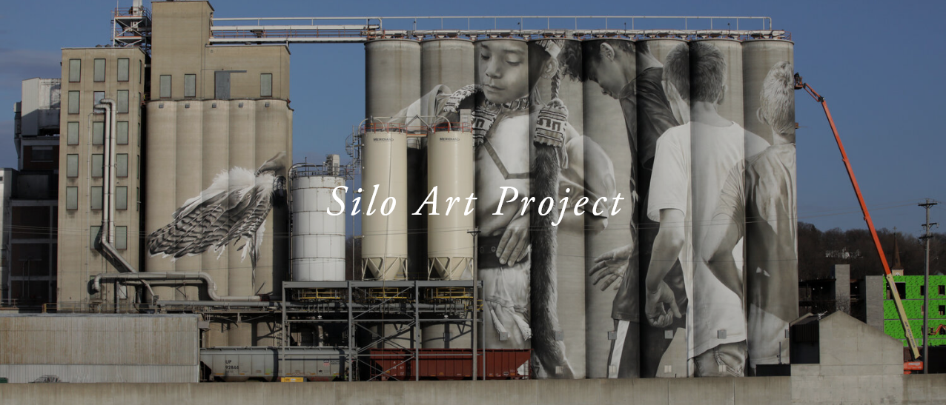
View of full silo mural, featuring children in motion. An orange crane lifts the artist to the top, right side.
CityArt Committee, Mankato, MN $300,000 | In 2018, CityArt commissioned international artist, Guido Van Helten to complete a mural on the 135-foot-tall silos Ardent Mills silos. Work began in 2019 the mural in Mankato stands as the latest installment in the continuation of a connected narrative throughout the Midwest celebrating identity and regional stories. In recent years, the Van Helten has installed celebrated works in Faulkton, South Dakota and in Fort Dodge, Iowa.
Van Helten visited Mankato in September 2018 then for another visit to get to know residents and to understand the history and narrative of the area prior to creating a design for this major public artwork. The concept is a summary of experiences, observations, and discoveries in color and culture in Mankato utilizing the Education Day at the Mahkato Pow Wow 2018/19 as a backdrop for the photographs on which the design of the mural is based.
This design combines the shared ideals of community, diversity, and inclusion; it pays respect to history while encouraging a positive dialogue on the future identity of the Mankato area. The mural is dynamic, with a comprehensible community focus that echoes the surrounding landscape and architecture. It is the intent for each viewer to derive their own meaning from the work; and it will ideally be an invitation for a fresh, direct and friendly dialogue to occur in the surrounding region as a result.

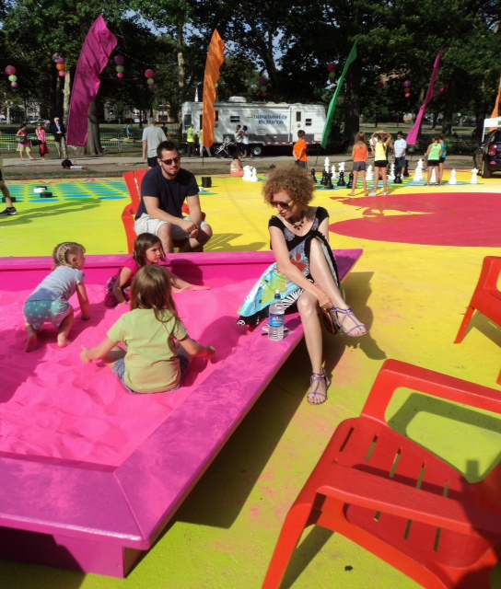
The artist is sitting with several children interacting with her colorful installation.
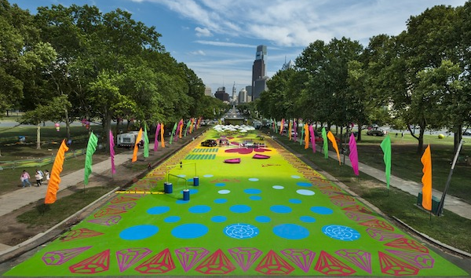
View of interactive art installation from the stairs of the Philadelphia Art Museum
aPA, Philadelphia, $104,731 | Magic Carpet" by artist Candy Coated was commissioned by the Association for Public Art (aPA) for THE OVAL, a temporary site with community programming, events, and activities organized by Philadelphia Parks and Recreation and Fairmount Park Conservancy. Candy Coated’s exuberant design included her signature decorative motifs rendered in vinyl, 3-D illusion art, brilliantly colored sandboxes, and fabric banners, among other unique attractions. An enthusiast of the decorative arts, Candy Coated's work brings together installation art, popular culture, fantasy, fashion, printmaking and a passion for vivid color.

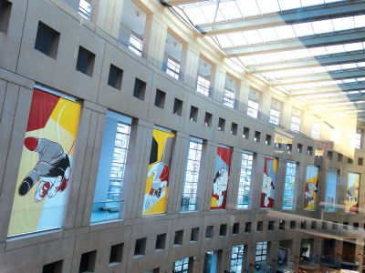
Left: transit shelter with “Teach, Honor, Hope” poster by Sonny Assu with designs in blue and orange.
Right: “Reconciliation” banners installed in windows of a city building.

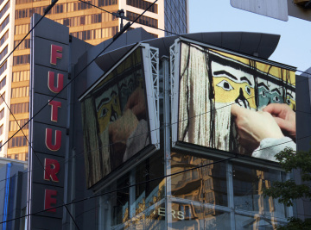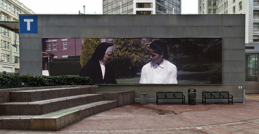
Left: video work installed on downtown advertising screens
Right: Video Work on large public screen in public viewing area

City of Vancouver, $95,350 | The Mayor and City Council of Vancouver proclaimed June 21, 2013, to June 20, 2014, as a Year of Reconciliation to stimulate awareness of the historical impacts of residential schools and racial injustices and to encourage reconciliation and healing. The Public Art Program invited artists from across Canada to propose new 2-D artworks about reconciliation for temporary platforms such as transit shelter posters, banners in the Vancouver Public Library downtown, a photo-mural at the Canada Line City Centre transit station and video works for three downtown advertising screens. Submissions were reviewed by a panel of Aboriginal artists and educators, 10 Aboriginal and non-Aboriginal artists were selected. Artworks premiered monthly from March - Aug. 2014, and displayed for a min. of 5 weeks (transit shelters) to a max. of 9 months (library banners & City Centre transit station).
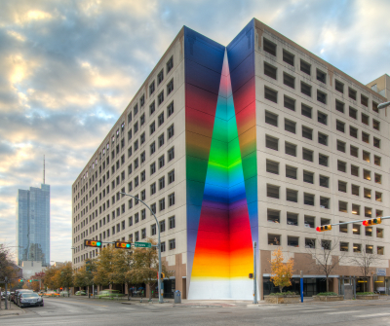
City of Austin, $74,000 | At ten stories and 103 feet tall, Tau Ceti creates a remarkable optic experience as sunlight from surrounding buildings refracts upon a painted gradient color spectrum throughout the day. Located in downtown Austin, the title of the artwork, Tau Ceti, references a single star in the constellation Cetus that is spectrally similar to our own sun. Kristofoletti, a native of Transylvania, painted the mural entirely by hand suspended from a motorized swing stage.

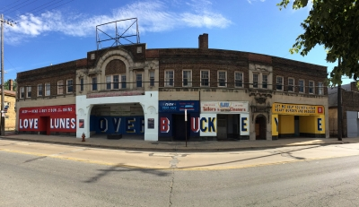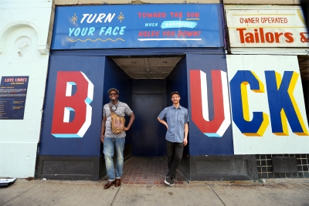
Cleveland LAND studio, $57,774 | “Love Lunes Over Buckeye” is a literary art project unique to Cleveland's Buckeye neighborhood, combining poetry and hand-painted signage to convey a message of love, hope, and inspiration. The project paired neighborhood spoken word poet Damien Ware with visual art firm, Little Jacket, and sign painting artist, Alan Giberson, to create a series of hand-painted lunes, a literary form similar to haiku, along the Buckeye Road commercial district. The project strives to cultivate a culture of communal sharing and encourages reading and writing as a means of empowering voice. This project emphasizes the importance of literacy by encouraging all participants to tell their story through written and spoken word. Programming involving poetry events, writing workshops, and other types of art activities provide hands-on opportunities for community engagement.

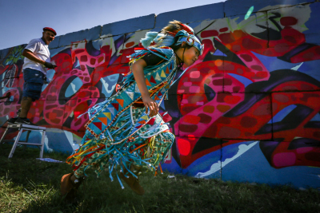
Young person in traditional, colorful garb speeds by artist painting the graffiti-style mural in background.

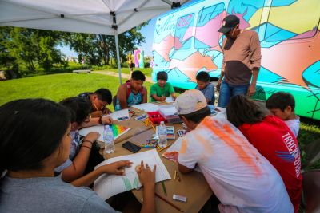
A teacher watches as a group of young artists create art, Rolling Rez bus in background.

Eagle Butte, SD $55,000 | The “RedCan” Graffiti Jam merges Lakota and graffiti cultures and celebrates individuality, positive self-expression, creativity and healing of the Cheyenne River community. Professional Native and non-Native graffiti artists traveled to the reservation from across the country to work with youth and local graffiti artists to art wash our rural, isolated town with culturally focused murals. It offered Cheyenne River’s young people and community an unparalleled opportunity to experience the contemporary graffiti art movement, learn about different techniques and styles, and paint alongside master artists from across the country.

Artists painted in 10 outdoor locations across the community, vendor booths were open in the Waniyetu Wowapi Art Park, and a youth traditional dance exhibition with youth drum group performed daily. Young people participated in art classes through First Peoples Fund’s Rolling Rez Arts bus that included skateboard painting and sugar paint spray art. The murals continue to be sources of pride and remain unmarred by tagging.
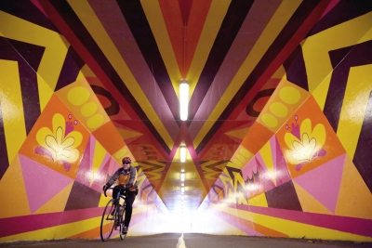
Washington Percent for Art, $32,000 | With the help of community volunteers, Kristen Ramirez has created an immersive experience of color and light in the Burke-Gilman Trail's bustling Wayne Tunnel, a gateway between communities and natural landmarks. Ebb & Flow combines blasts of bright yellow, orange, pink, and purple, symbols that represent the flora and fauna of the region, and the tunnel's own architecture to make a playful kaleidoscope for trail users to enjoy.
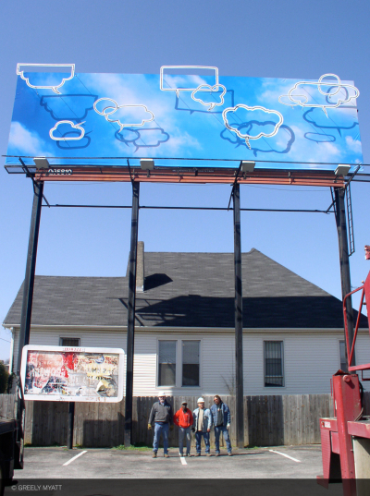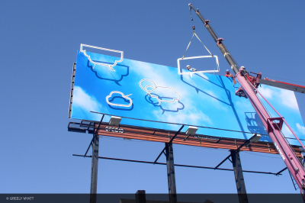
Memphis UrbanArt Commission, $5,000 | This budget reflects one mural out of ten temporary billboards around Memphis by local and national artists for the UrbanArt Commission’s 10th Anniversary Interactions/Interruptions citywide exhibition.

Memphis artist Greely Myatt designed and fabricated “Cloudy Thoughts,” taking his inspiration from comic strips, Myatt fashioned painted aluminum and steel into 10 word bubbles. With nine of the figures designed as speech bubbles and one as a thought bubble, the work reflects the political discourse evident across some of the areas of the United States government today. Installed throughout the month of May, the billboard inspired discussions about the arts, the use of quotidian space, and advertisement arenas used by our current society.

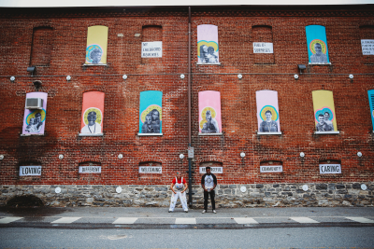
Artist led aspect of neighborhood renovation, $800 | The mural was the final product and one small budgetary portion of a 4 months of community engagement around the upcoming renovation of a neighborhood park. The first phase of community engagement in Culliton Park consisted of four key elements: free pop up arts and crafts in the park, a community zine making and pizza party day, a temporary community mural, and a series of small public art projects. “Art Pop” was offered throughout the summer mostly on weekends. It featured a tent painted to resemble a circus tent, a table, and supplies for a variety of arts and crafts projects. Anyone was invited to come to the table, sit down, and make something to take with them or hang on the chain-link fence that borders the park.
“’Art Pop’ was a result of feedback I gleaned from the community. Many parents were wary that their children wouldn’t have anything to do artistically when school let out. With the funds designated to community engagement, I purchased bulk materials from a local second-hand arts and crafts supplies store and brought them once or twice a week to the park. Each subsequent project- the zine, the mural, and the small public art projects- were products of conversations held during “Art Pop”.
https://www.americansforthearts.org/by-program/networks-and-councils/public-art-network/public-art-year-in-review-database/this-neighborhood-isportraits-of-culliton-park-neighbors

