*Updated August 2024*

Nebraska’s

Arts Education

Data Project

Nebraska’s Arts Education Data Project was made possible with generous funding support from the Nebraska Arts Council.

User Guide

# Introduction

Welcome to the Nebraska Arts Education Data Project. This exciting project is a collaborative effort between the Nebraska Department of Education’s Offices of Teaching, Learning, and Assessment, Data, Research, and Evaluation, the Nebraska Arts Council and Quadrant Research. Additional collaborators include Nebraskans for the Arts, the Nebraska Cultural Endowment, the State Education Agency Directors of Arts Education, Nebraska’s local school districts, and many arts education organizations and stakeholders.

Bringing the vibrant world of arts education to life through data, Nebraska’s Arts Education Data Project is part of a national snapshot of arts education. The interactive data visualization tool allows users to explore enrollment, access, and participation in the arts throughout Nebraska's public school system.

This dashboard is a result of generous funding from the Nebraska Arts Council and reflects NDE’s and NAC’s shared commitment to nurturing arts learning and creative expression in Nebraska’s youth. While the Arts Education Data Project focuses on numbers, it is important that our students’ arts education goes beyond numbers to tell stories—how the impact of instruction in visual & media arts, dance, music, and theatre have lasting impacts and shape the futures of our youth.

Decorative photo of a person drawing on a piece of paper.

Through interactive charts and graphs, users can uncover trends, identify opportunities, and begin to identify and discuss challenges. The goal of the project is to make this information accessible and to be an impetus for dialog, collaboration, and brainstorming. Together we can ensure every student in Nebraska has opportunities to learn, explore creativity, and hone the processes, skills, techniques, and connections that allow for artistic expression and understanding, connecting all of us to the human experience.

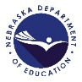Users are invited to dive in, explore the data, and join us in working to promote arts education in Nebraska. Let's celebrate the arts and empower our students to unleash their creativity. Thank you for joining us on this exciting journey of discovery and collaboration.

*The mission of the Nebraska Department of Education*

*is to lead the preparation for all Nebraskans for learning, earning, and living.*

# Getting Started with the Arts Education Data Project (AEDP)

## Arts Education Data Project Logo. Words with icons of two eighth notes for music, a paint brush for visual arts, drama masks for theatre, two dancers for dance, and books for media arts. What is the purpose of Nebraska’s AEDP?

The intention of Nebraska’s Arts Education Data Project (AEDP) is to promote meaningful dialogue about arts education in our state and to encourage equitable and data-informed decisions supporting well-rounded education for all Nebraska students.

## Who Can Use Nebraska’s AEDP?

Nebraska’s AEDP is designed for easy navigation by educators, school administrators, policymakers, parents, and the public.

## What are some of the benefits of Nebraska’s AEDP?

* Empowers school districts and stakeholders with data for informed decision making that supports strong learning networks for arts education programs.
* Enables Nebraskans to see the arts education courses offered in public schools across the state.
* Provides information about arts education course access, enrollment, and participation at the school level, the district level, and statewide.
* Provides detailed information about arts instruction trends over time.
* Helps illustrate where there may be gaps in access to arts education instruction in our state.

## What is not included in the AEDP?

The AEDP comprises only arts education data for courses that are offered for credit or satisfy academic requirements during the school day. Therefore, data from activities outside of the school day, such as theatre programs, dance teams, music ensembles, or art clubs, is not found in the AEDP.

# User Guide Contents

Introduction 3

Getting Started with the Arts Education Data Project (AEDP) 4

User Guide Contents 5

Dashboard Overview 6

Dashboard and Navigation Tips 7

Key Terms 9

Table of Contents (TOC) View 12

Overview 14

District-Level Arts Education View 18

Arts Disciplines Explorer View 20

Trends Over Time View 22

School Profile View 23

No Arts View 27

Course Codes, Endorsements, and Accreditation 28

Frequently Asked Questions 30

How Do I Learn More? 32

# Dashboard Overview

## About the Dashboard

The Nebraska Arts Education Data Dashboard allows users to review aggregate data at the school, district, county, and state levels. The interactive, color-coded dashboard displays arts access, enrollment, and participation data for Nebraska’s 244 public school districts, as reported annually via the state’s longitudinal data system. Data from ensuing school years will be added annually, showing the status of arts education over time.

Getting Started

Access the dashboard from the Nebraska Department of Education’s Arts Education website, [education.ne.gov/finearts/](https://education.ne.gov/finearts/), the Nebraska Arts Council website, [artscouncil.nebraska.gov](https://www.artscouncil.nebraska.gov/) or by selecting Nebraska from the participating states on the National Arts Education Data Project’s website, [artseddata.org](https://artseddata.org/).

From the landing page, click any of the blue buttons or use the tabs across the top of the page to explore the corresponding view.

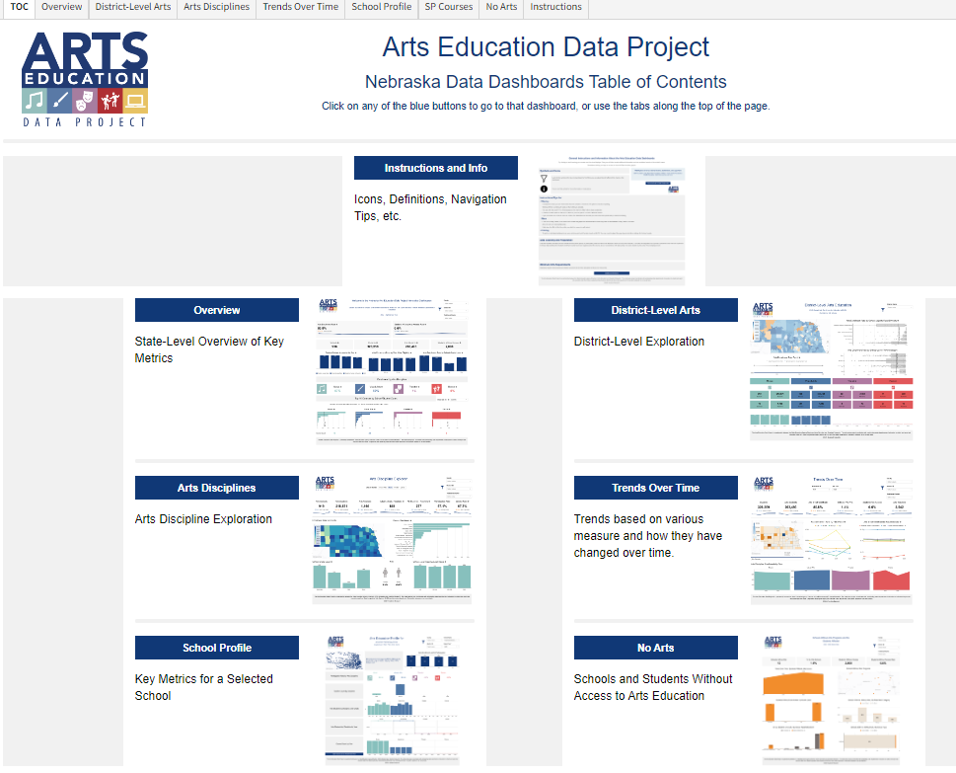

# Dashboard and Navigation Tips

## Symbols and Icons

Filtering icon depicting a funnel. Click this icon to access the **filtering options** to customize a search. that affect all charts on the dashboard.

Click this icon to **clear the filter**.

Hover over this symbol **for more information** or instructions. If the button is not displayed, increase the size of the browser window.

Minimize Element Icon. Two arrows pointing from the top right and bottom left corners to the middle of a square. Maximize Element Icon. One arrow pointing to the top right. One arrow pointing to the bottom left. Select this icon to **maximize the element**. The graphic will display in a full browser window and may also include the data chart or list.

More Menu Icon. Three dots placed arranged vertically. After viewing a maximized element, select this **minimize element icon** to return to the previous view. It is in the top right of the browser window and may only appear when a cursor is moved over it.

The **more menu** allows users to sort, export, and refresh a graph, chart, or other element.

## Maps, Graphs, and Printing

* Click on a county, district, or a school’s dot on maps to filter the graphs on the dashboard to show only data for the selected county, district, or school.
* Hold down the CTRL or CMD key while clicking to multi-select data points on maps or graphs.
* To print an individual dashboard, use a web browser’s print function, such as CTRL+P. Page layout and other settings may need to be adjusted for the best result.

## Filtering

* Checkboxes allow users to make more than one selection. Check the “All' option to include everything.
* Click the small "x" by the element that appears to the right of a filter's title to clear a selection.
* A blank space at the top of a filter list indicates it may be used to search. If there are more than 200 elements, the dashboard view only shows the first 200 choices.
* If a chart has been selected for filtering, clicking elsewhere on the chart will reset the filtering.

## User Tip

Look for this symbol throughout this User Guide for tips on using Nebraska’s Arts Education Data Project.



# Key Terms

For a complete list of terms used for all states participating in the Arts Education Data Project, visit [artseddata.org/definitions/](https://artseddata.org/definitions/).

## Course Codes

The Arts Education Data Project is built around enrollment, access, and participation data and relies on information that is reported to the Nebraska Department of Education annually through its Course Codes and Clearing Endorsements collection. For the purposes of the project, it is important to understand that ***only*** courses for which students earn instructional units are included. While arts education instruction can and does occur outside of the school day through activities such as jazz bands, art clubs, play and musical productions, etc., these are not included in the project because students do not earn credit for participation, nor is there a uniform reporting mechanism. For complete information on course codes, see the Course Codes, Clearing Endorsements, and Accreditation section on page 27 of this guide.

## Data Suppression

For confidentiality, and in compliance with the Family Educational Rights and Privacy Act (FERPA), and state guidelines, data from courses with fewer than 10 students is suppressed. The course or category will appear, but no numbers will be shown.

## Free and Reduced Price Meals

The percentage of students eligible for Free or Reduced-Price Meals (FRPM) under the National School Lunch Program provides a proxy measure for the concentration of low-income students within a school.

Children from families with incomes at or below 130% of the poverty level are eligible for free meals. Those from families with incomes between 130% and 185% are eligible for reduced-price meals. Public schools are categorized according to FRPM eligibility.

* **High poverty** = more than 75.0% of the students are eligible for FRPM
* **Mid-high poverty** = 50.1% to 75.0% of the students are eligible for FRPM
* **Mid-low poverty** = 25.1% to 50.0% of the students are eligible for FRPM
* **Low poverty** = 25.0% or less of the students are eligible for FRPM

## No Arts/Access

* **Students without Arts**is the number of students who are attending a school that does not offer arts courses.
* **No Arts Schools/Arts Not Offered** are schools that do not offer arts courses.

## Image of a student playing a flute. The student is wearing a striped shirt. School Grade Level

School grade levels are defined as:

* **Elementary** = grades K-5
* **Middle** = grades 6-8
* **High** = grades 9-12
* **Mixed** = schools with divisions that are not elementary (grades K-5), middle (grades 6-8), or high school (grades 9-12).

## School-Majority Race/Ethnicity

In these dashboards, the majority race/ethnicity is a school-level variable rather than a student-level variable. If a certain race or ethnicity is named as the majority for a school, it means the greatest number of students of the total school population is of that race or ethnicity.

## Student/Teacher Ratios

* **All students – Arts teachers ratio**: The total number of students divided by the number of arts teachers.
* **Arts students – Arts teachers ratio**: The number of students enrolled in any arts course divided by the number of arts teachers.

Teachers who teach more than one course in the same discipline are only counted once. Teachers who teach across disciplines are counted once per discipline. Likewise, teachers who may teach at more than one school are counted only once.

Teachers who are cleared to teach a particular course, as indicated by Rule 24: Teaching Endorsements, can be considered arts teachers for this project, even if they have a certification that is not music, visual art, theatre, or physical education (for dance). For example, a second grade teacher who also teaches visual art is considered an arts teacher in this project, even though the teacher does not have a visual art certification. See the Course Codes, Clearing Endorsements, and Accreditation section on page 27 for more information.

## Uptake Rate

Uptake rate is the percentage of students participating in arts education courses based only on schools offering the discipline (music, visual art, theatre, or dance). This is the true participation rate based on schools in which the program is offered, as opposed to a measure against all schools/students regardless of the presence of the program. It is most useful for subjects that have smaller numbers of enrollment, such as dance and theatre.



# Table of Contents (TOC) View

The table of contents contains six dashboards that comprise the Arts Education Data Project. These dashboards are consistent amongst all states participating in the project. Arts education data can be accessed by the following:

* **Overview** – state-level overview of key metrics
* **District-Level Exploration** – metrics of an entire school district
* **Arts Disciplines** – data by subjects of visual arts, music, dance, and theatre
* **Trends Over Time** – trends based on various measures and how they have changed over time
* **School Profile** – key metrics for a selected school
* **No Arts** – School and students without access to arts education

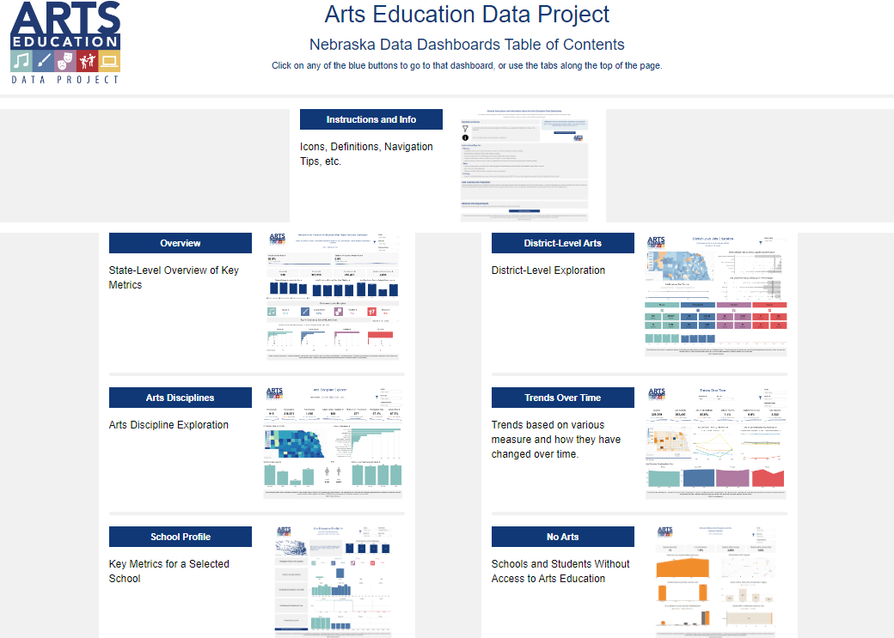

## Navigating the Dashboard

A dashboard may be selected from the Table of Contents view or the tabs at the top, as shown in the orange box below.

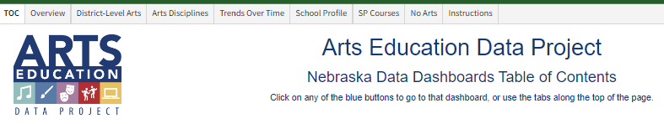

S

# Overview

## State-Level Overview of Key Metrics

The **Overview Dashboard** presents state-level data in a concise format. Two key percentages are presented on the left side of the top row—**Arts Enrollment Rate** and **Students Without Access Rate.** These data points provide localized data in other views or tabs.

The next row shows the number of schools and students in Nebraska, followed by the number of students enrolled in arts education courses, as well as the number of students who do not have access to arts education.

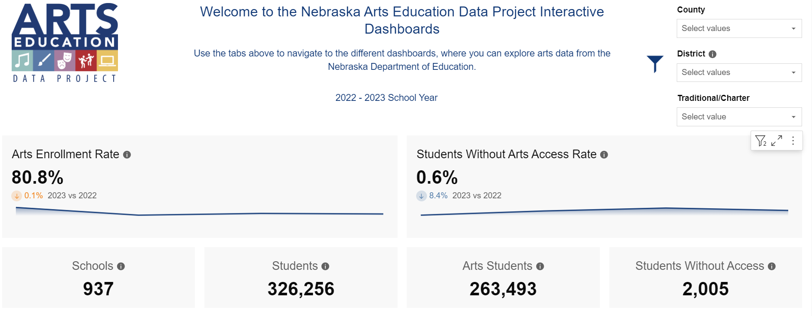

## Important Note

The Nebraska Department of Education compiled the data as submitted by individual school districts. A small percentage of schools (0.6%) show as no arts for SY 2022-2023. Even though these schools did not report arts education course enrollment, contact with these schools indicates that courses were in place. Increased guidance and review of data reporting is in place for future years.

## Access and Enrollment Metrics

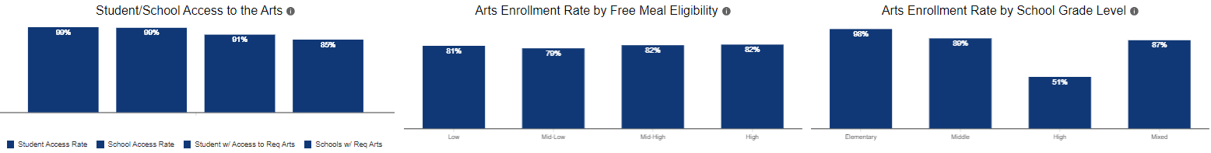The three bar graphs present percentages by certain categories, such as free meal eligibility and grade level.

The bar graphs are shown in greater detail below, along with information that appears when hovering over the corresponding information icon.

## A bar graph showing the students/school access rate to arts education.Students/School Access to the Arts

This chart shows:

* **Student access rate** = the percentage of schools providing any arts courses
* **School access rate** = the percentage of students attending those schools
* **Students with access to required arts** = the percentage of schools offering the required number of disciplines
* **Schools with required arts** = the percentage of students attending

## A bar graph showing the arts enrollment rate by free meal eligibility categories. 81% = low, mid-low = 79% mid high = 82%, and high = 82%. Arts Enrollment by Free Meal Eligibility

The percentage of students eligible for free or reduced-price meals (FRPM) under the National School Lunch Program provides a proxy measure for the concentration of low-income students within a school.

Children from families with incomes at or below 130% of the poverty level are eligible for free meals. Those from families with incomes that are between 130% and 185% of the poverty level are eligible for reduced-price meals.

In this indicator, public schools are divided into categories according to FRPM eligibility. This is the percentage of schools by student majority of the category.

* **High poverty** = more than 75.0% of the students are eligible for FRPM
* **Mid-high poverty** = 50.1% to 75.0% of the students are eligible for FRPM
* **Mid-low poverty** = 25.1% to 50.0% of the students are eligible for FRPM
* **Low poverty** = 25.0% or less of the students are eligible for FRPM

## A bar graph showing arts enrollment rate by school grade level. 98% elementary, 89% middle school, 51% high school, 87% mixed schools. Arts Enrollment Rate by School Grade Level

For the project, school grade levels are:

* **Elementary** = grades K-5
* **Middle** = grades 6-8
* **High** = grades 9-12
* **Mixed** = schools with divisions that are not elementary (grades K-5), middle (grades 6-8), or high (grades 9-12)

## Enrollment by Arts Discipline

This graphic shows the percentage of students who are enrolled in music, visual arts, theatre, and dance.

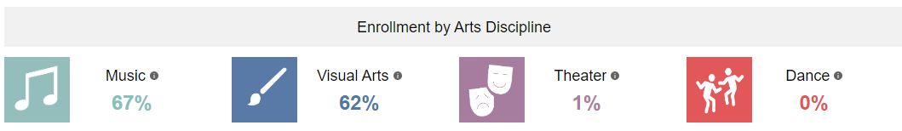

## Top 10 Courses by School/Student Count

The next section shows the top ten courses in each subject area. Hover over the bar to find the title of the course and the number of students.

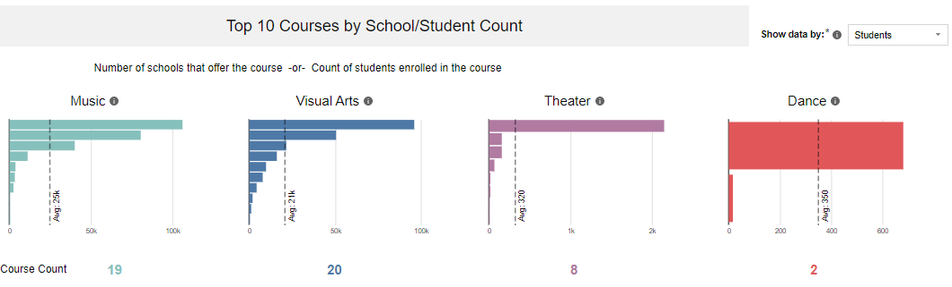

Filter this section to show the data by students or schools, as indicated in the orange box below.

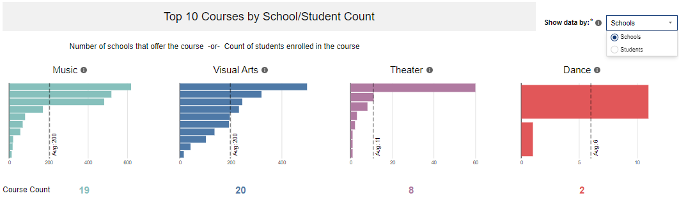

## Filtering by County and District

The overview dashboard may also be filtered by county and/or district. To do so, select the filter in the top right corner of the dashboard as indicated by the orange box below. Adding filters will change the data for all metrics on the page, showing only information for the county and/or district selected.

Use “x” to clear filters.

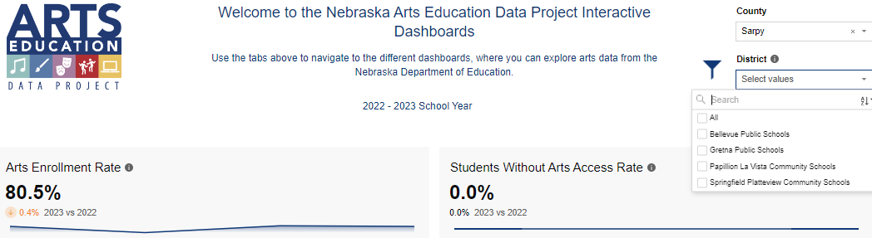

# District-Level Arts Education View

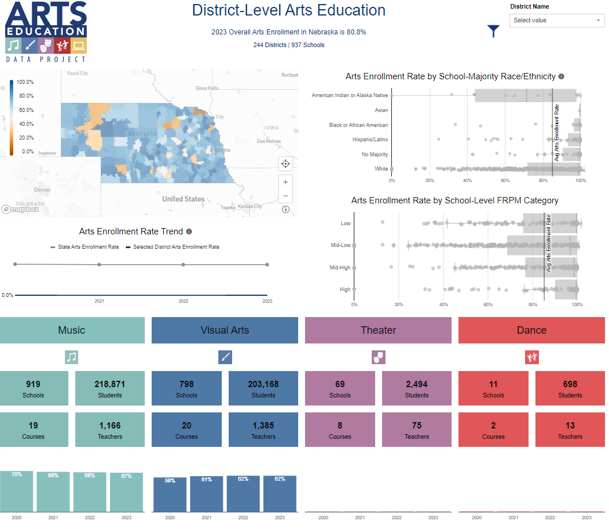The district-level arts view contains information that can be filtered by a school district. Select the district in the top right corner of the dashboard view. There are several main parts of the default view in the **District-Level Arts View** tab.

* The map displays district boundaries for Nebraska public schools and is clickable by district. Selecting a school district will engage the district filter.
* The **Arts Enrollment Rate by School-Majority Race/Ethnicity** and **Arts Enrollment Rate by School-Level FRPM (Free and Reduced Public Meals)** charts on the right display clickable plots and are thus filterable for each school reporting marking arts enrollment for each category. It’s important to note that this information is reported by school majority. See the Key Terms section on page 8 of this guide.
* The **Arts Enrollment Trend** line graph shows overall enrollment across Nebraska for the years indicated.
* The **colored boxes at the bottom** display data for each discipline, including the number of schools, courses, students, and teachers.

If a selected district does not appear, be sure to clear filters from other tabs.

Use the District-Level Arts Education tab to compare district data to state averages, or to districts of similar size, location, etc. The information can provide empirical evidence when supporting the need for equitable access to arts education.

## Enrollment Rate Trends

The **District Level Arts** view can be effective in demonstrating how a specific district’s enrollment relates to the state average. For example, users can identify enrollment increases or declines over time, or compare enrollment at a particular school district with the state average.

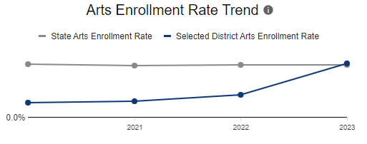

The District Level Arts view also contains metrics for various data points and can be used to advocate for equitable access to arts instruction. For example, if a school with a particular demographic population has lower enrollment than the state average, this information could be used to highlight the need for increased access to arts instruction.

# Arts Disciplines Explorer View

The **Arts Disciplines Explorer** viewallows users to understand which schools offer visual art, music, theatre, and/or dance courses quickly and easily.

Begin by selecting an arts discipline. The colors of this view are consistent with the colors of the disciplines throughout the entire dashboard: visual arts is blue, music is green, theatre is purple, and dance is red. This filter is shown in the orange box below.

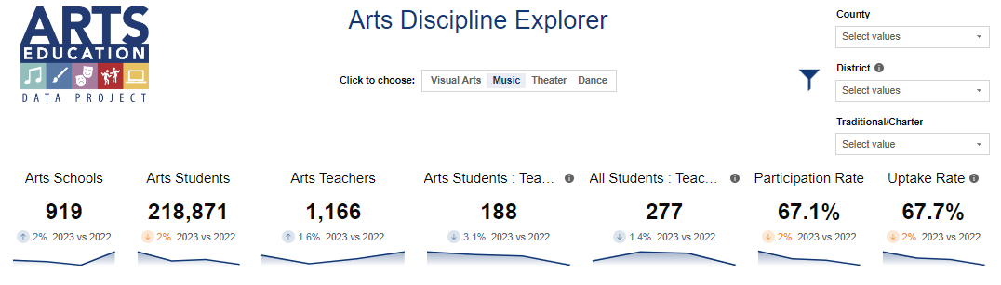

The first section of the Arts Discipline Explorer shows the number of schools, students, teachers, teacher-to-student ratios, participation rates, and uptake rates (see Key Terms, page 8). Trends for the prior year are also included beneath the number. The graphic above displays music education for SY 2022-2023.

## Enrollment Rate by County and Course

The second section shows enrollment rates by county and course. Hover over the county or bar for a certain course and specific data for that county or course will appear. Click a county to filter the data. The example below is music for SY 2022-2023.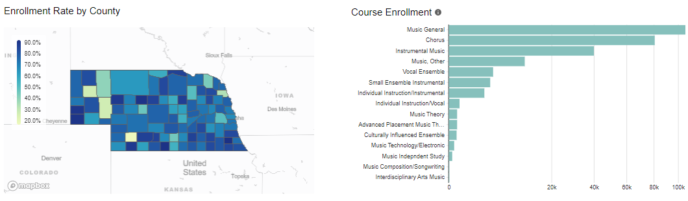

## School Grade Level, Gender, and School-Level Free/Reduced Meals

The third section shows enrollment in the discipline by grade level, gender, and school-level free/reduced meals.

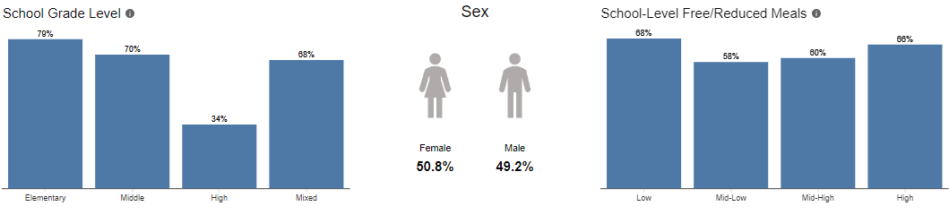

The example above displays visual arts education statewide for SY 2022-2023.

## Filter by County or District

Filters in the top right offer the selection of certain counties or districts, thus allowing the display of information for that specific county or district. The example below is for Hall and Adams counties. The filter is indicated by the orange box.

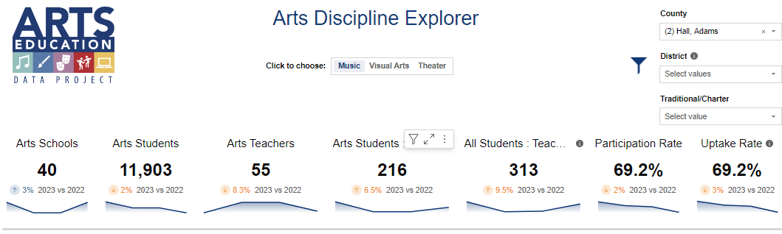

The Arts Discipline Explorer View can be useful to understand where specific areas of the state may not offer a particular arts discipline, or where a particular arts discipline is very prevalent. The data that result from this inquiry could be used to identify where there are gaps in various arts disciplines in our state.

# Trends Over Time View

The **Trends Over Time** view can be helpful in seeing changes in enrollment and participation over time for various categories. Information can be filtered by years, counties, and/or districts.

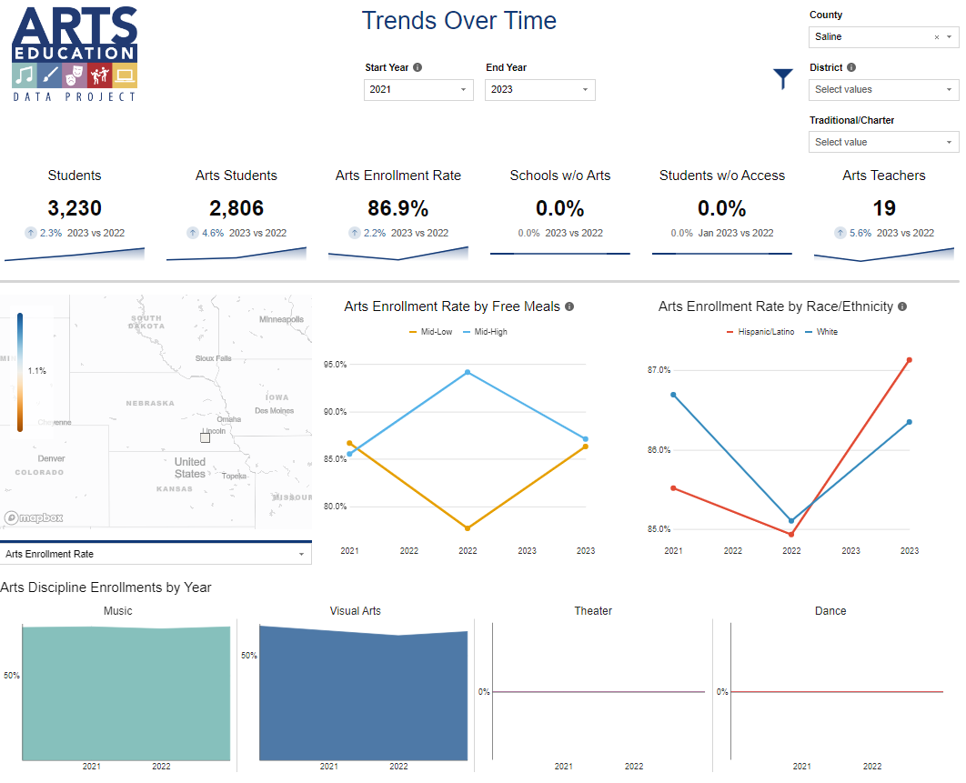

The graphic above shows arts enrollment trends from SY 2020-2021 to SY 2022-2023 for all schools in Saline County.

The top section explains changes in six categories: the number of students, the number of arts students, the arts enrollment rate, the percentage of schools without access to arts education, the percentage of students without access to arts education, and the number of arts teachers. The graphic above shows a 2.3% increase in the total number of students and a 4.6% increase in the number of students participating in arts education.

# School Profile View

Key metrics for a specific school can be accessed by selecting filters for a specific county, district, school building, and year (see example below).

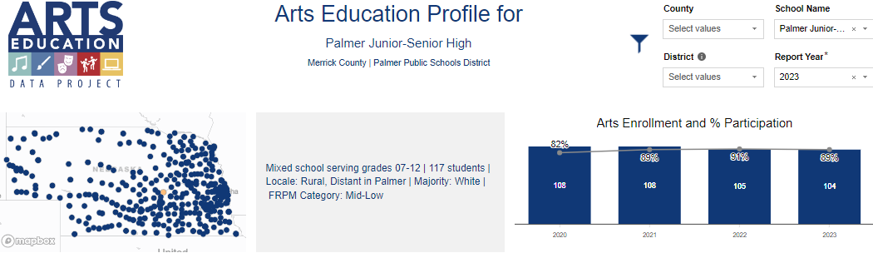

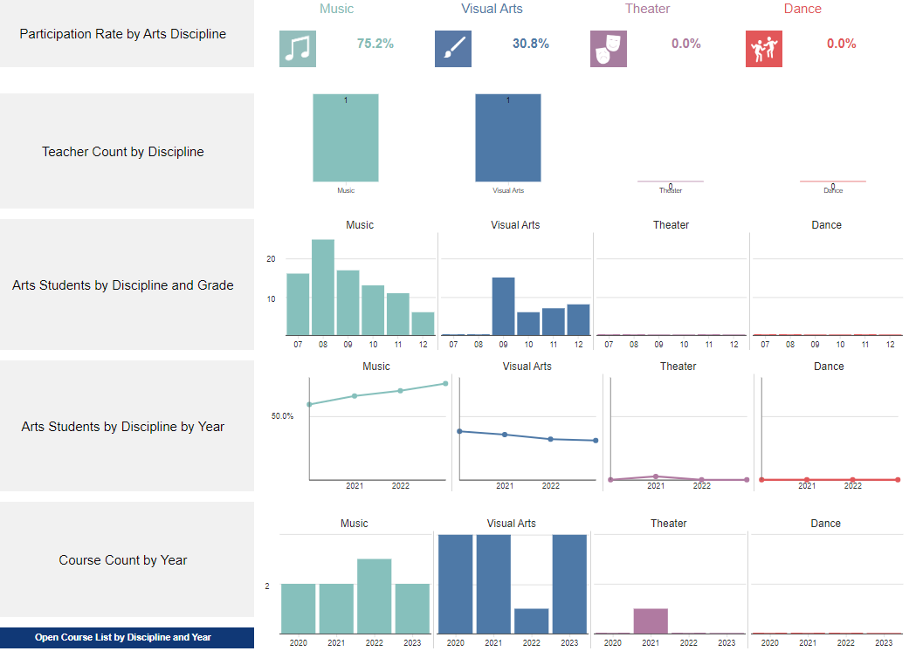The **School Profile** view provides participation rates by arts discipline, the number of arts teachers by discipline, the number of students by discipline and grade, and enrollment trends and course counts by year.

Hover over the bars in the **Arts Students by Discipline and Grade** to see the actual numbers. Hover over the plots on the **Arts Students by Discipline by Year** to see the percentage of participation.

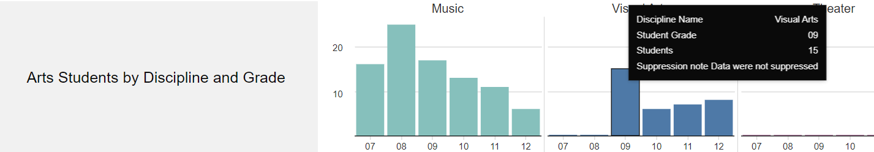

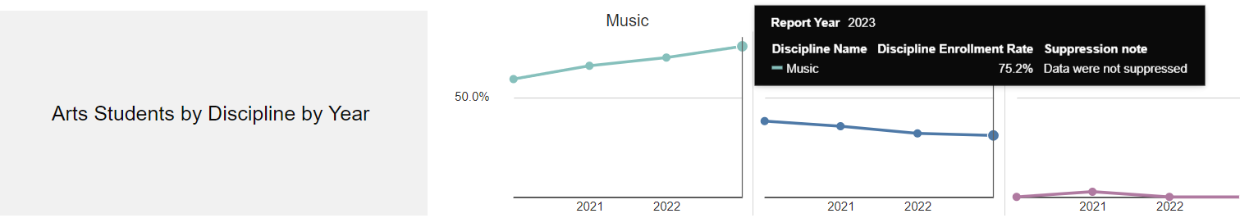

## Course Lists

To learn more about the courses that are offered, select **“Open Course List by Discipline and Year”** at the bottom left. This will open a view that lists the courses that are offered.

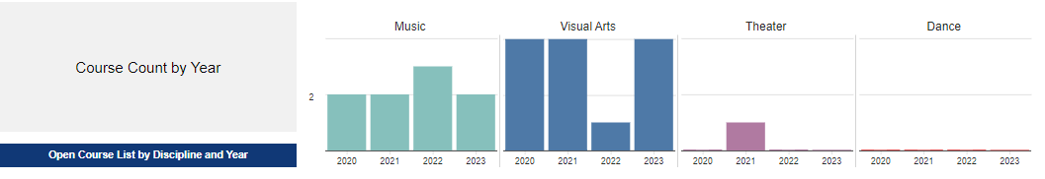

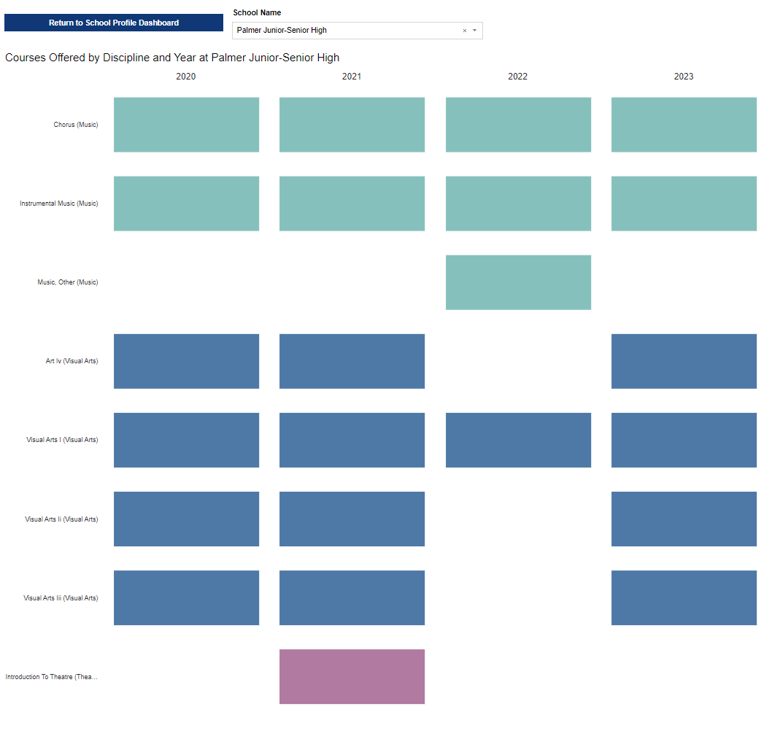

One of the primary purposes of Nebraska’s Arts Education Data Project is to provide an impetus for dialog. It’s not just about the numbers. Knowing the courses that are taught offers ways for schools and teachers to develop their arts education programs, engaging their students in arts learning. Schools and teachers may want to find ways to enhance their current program of study or try something different or new. They can reach out and connect with other schools to learn how the program of study came to be and discuss any challenges they may have faced in implementing the changes.

Collaboration across schools is especially helpful for music courses that are not performing ensembles, for example music technology, composition, piano, guitar, etc. Schools may want to consider changing a visual arts program from comprehensive courses to media-specific courses such as pottery, jewelry, or print making. Collaboration can also help teachers connect in areas like theatre and dance where access has historically been less than in other arts disciplines.

## Decorative Photo. Dice set on their side that spell TEACH with books stacked in the background. Special Note – Course Code Updates

The NDE updated the arts education course codes for SY 2023-2024. Unusually high numbers of enrollments in “Music – Other” and “Visual Arts – Other” indicated that previously available course codes lacked specificity. Each school district reviewed its course codes, adjusting course reporting to the updated course codes.

## Looking Forward

The NDE plans to monitor course enrollment reporting and advise districts of changes that should be considered. Doing so will improve the specificity of the data that is reported in subsequent years. This will help Nebraska’s Arts Education Data Project users have a clearer picture of arts education in the state in future years.

# No Arts View

**Nationally**, there are schools that report no access to arts education for a variety of reasons. Therefore, the AEDP provides a **No Arts view**. Information in this section may be used to explore resources or conditions that exist that preclude students from accessing arts education. The **No Arts view** can also highlight potential resources needed for certain geographic regions.

**In Nebraska**, a small percentage of schools (only 0.6%) show as No Arts for SY 2022-2023. The Nebraska Department of Education compiled the data as submitted by individual school districts. Even though these schools did not report arts education course enrollment, contact with these schools indicated courses were in place. Increased guidance and review of data reporting is in place for future years.

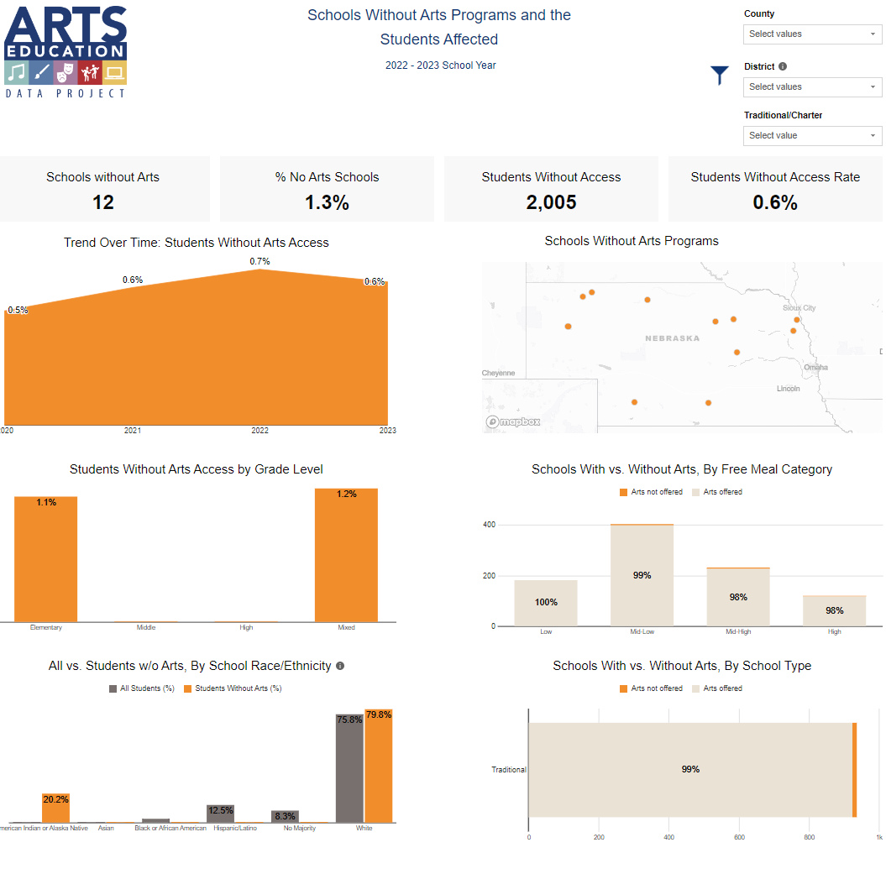

# Course Codes, Endorsements, and Accreditation

## Course Codes

Course Codes are numeric codes assigned to courses taught in Nebraska’s schools. Each district reviews its course offerings and uses its student information system to report course enrollments to the Nebraska Department of Education.

Arts education courses are found in four subject areas: visual arts (including media arts), music, theatre, and personal health and physical fitness (dance courses). These courses satisfy Nebraska’s Rule 10 Accreditation Regulations.

For purposes of the arts education data project, all states’ course codes are standardized against the National Center for Educational Statistics’ SCED (School Courses for the Exchange of Data) codes. A crosswalk of Nebraska’s course codes to SCED codes has been completed and provided to Quadrant Research.

For complete information on Nebraska’s course codes, visit [coursecodes.education.ne.gov/](https://coursecodes.education.ne.gov/). For guidance and user information on Nebraska’s Arts Education Course Codes, visit [www.education.ne.gov/finearts/fine-arts-course-codes/](http://www.education.ne.gov/finearts/fine-arts-course-codes/).

## Decorative photo of theatre class. Three students sitting, facing away from, practicing lines, with scripts in hand. Another student actor is standing in the background. Teaching Endorsements

Nebraska’s Rules 20 and 24 govern educator preparation programs. The following endorsements are available for arts educators:

* Visual Arts – grades K-12 field endorsement or middle level visual arts subject endorsement
* Music – grades K-12 field endorsement for instrumental and vocal music, or vocal music subject endorsement
* Theatre – supplemental endorsement
* Physical Education – for those wishing to teach dance.

Both Nebraska’s Rule 10, Accreditation Regulations, and Rule 14, Approval Regulations, require that certain percentages of F.T.E. (Full Time Equivalency) elementary and middle grade teachers hold appropriate endorsements and that certain percentages of instructional units at the secondary grades be assigned to teachers holding appropriate endorsements. For teachers to be considered appropriately endorsed for their assignments, they must teach the grade levels and subjects indicated on their certificate. Each course found in Nebraska’s Course Codes lists Clearing Endorsement(s), which is the endorsement required for the teacher of record.

In some cases, arts education courses can be taught by teachers holding certificates with teaching endorsements that are not music, visual arts, theatre, or physical education (for dance). For instance, an elementary certified teacher can teach visual arts and music. For complete information on Nebraska’s Rule 24, Guidelines Recommended for Use with Rule 24 (Endorsements), visit [education.ne.gov/educatorprep/information-for-institutions/rule-24-endorsement-status/](https://education.ne.gov/educatorprep/information-for-institutions/rule-24-endorsement-status/).

## Decorate photo of a student wearing an apron using a pottery wheel to make a clay pot. Accreditation

For complete information on Nebraska’s Rule 10, Regulations and Procedures for the Accreditation of [Public] Schools, visit [education.ne.gov/apac/accreditation-rule-10/](https://www.education.ne.gov/apac/accreditation-rule-10/). For complete information on Nebraska’s Rule 14, Regulation and Procedures for the Legal Operation of Approved Nonpublic Schools, visit [education.ne.gov/apac/approval-rule-14/](https://www.education.ne.gov/apac/approval-rule-14/) .

Rule 14 schools are only included in Nebraska’s Arts Education Data Project if they choose to report their course offerings and enrollment, access, and participation data.

# Frequently Asked Questions

## How do I access the dashboard?

Access the dashboard from the Nebraska Department of Education’s Arts Education website, [education.ne.gov/finearts/](https://education.ne.gov/finearts/), the Nebraska Arts Council website, [artscouncil.nebraska.gov](https://www.artscouncil.nebraska.gov/), or by selecting Nebraska from the participating states on the National Arts Education Data Project’s website, [artseddata.org](https://artseddata.org/).

## Decorative photo of acting class. Three students and instructor putting hands together in middle in support. How do I access enrollment numbers for the school district where I live?

The **District Level Arts** tab contains information on visual arts, music, theatre, and dance enrollment, access, and participation. Find out more about the District Level Arts view on page 17 of this guide. If you’d like to find out more detailed information about a particular school, look at the **School Profile** tab. See information on the School Profile view on page 22 of this user guide.

## I’m preparing a presentation and want to include arts enrollment totals reflective of the entire state. Where can I find that information?

Statewide enrollment totals are available at the top of the **Overview** tab of the Dashboard. Contextual information for each data point is also included. Learn more about the Overview tab on page 13 of this user guide.

## How do I find out if a school district does not offer any arts courses?

This information can be found in the **No Arts** tab of the dashboard. You can also use the map of Nebraska to select the school or district. More information on the No Arts tab can be found on page 26 of this user guide.

## Who do I contact if I have further questions about Nebraska’s Arts Education Data Project?

For more information about Nebraska’s Arts Education Data Project contact:

* Cody Talarico, Arts Education Specialist, Office of Teaching, Learning, and Assessment, Nebraska Department of Education, [cody.talarico@nebraska.gov](mailto:cody.talarico@nebraska.gov)
* Anne Alston, Program Specialist for Arts Education, Nebraska Arts Council, [anne.alston@nebraska.gov](mailto:anne.alston@nebraska.gov)

## How often is the data on the Dashboard updated?

The most recent school year reflected in the data is always listed at the top of the dashboard. Data will be typically updated in the spring, subject to data reporting and verification, as well as the data sharing agreement between the NDE and Quadrant Research. If you have specific questions about the accuracy of the available data, please contact NDE Arts Education.



# How Do I Learn More?

## What if I want to know more about education in Nebraska?

To learn more about education in Nebraska, visit the Nebraska Department of Education’s website at [education.ne.gov](https://www.education.ne.gov/tcert/). If you’re interested in finding more education data, visit the Nebraska Education Profile at [nep.education.ne.gov](https://nep.education.ne.gov/).

## How do I become a teacher in Nebraska?

The mission of the Nebraska Department of Education is to lead and support the preparation of all Nebraskans for learning, earning, and living. If you want more information on becoming a teacher in Nebraska, visit Nebraska’s Educator Certification website at [education.ne.gov/tcert/](https://www.education.ne.gov/tcert/).

## How do I learn more about arts education in Nebraska?

To learn more about arts education in Nebraska, visit the NDE’s Arts Education website at [education.ne.gov/finearts](https://www.education.ne.gov/finearts/fine-arts-course-codes/). Access resources for arts education, read the arts education standards, sign up for the Fine Arts Education EXPRESSIONS newsletter and more.

## Decorative photo or orchestra. Students playing violins, violas, cellos, and string bass. How do I learn more about the arts in Nebraska?

The Nebraska Arts Council aspires to positively impact lives of Nebraskans through the power of art. NAC provides programming, grants, and opportunities to foster creative innovation statewide. Visit the Nebraska Arts Council’s website at [artscouncil.nebraska.gov](https://www.artscouncil.nebraska.gov/) to learn more.

Photographs from prexels.com (no attribution required). Logos used with permission. Graphs, tables, and charts from Nebraska’s Arts Education Data Project. Nebraska’s Arts Education Data Project User Guide is licensed under Creative Commons by NC-SA and prohibits commercial use. Open to use, share, and change for non-commercial use. Users must share back content using the original Creative Commons license.